39.65: a) 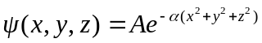 but the distance to the origin is just 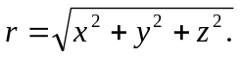
So, doing a change of variable.
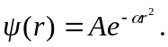
However, the probability is the integral of this function over all space. It is best to think of the volume integral in spherical coordinates where 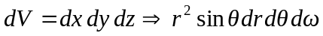 Now 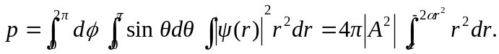 Thus we interpret the probability of finding a particle in a spherical shell between r and r+dr as 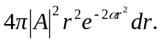
b) 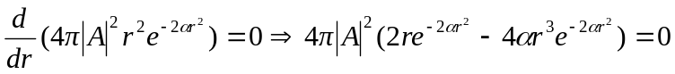
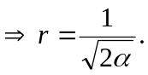This is not the same as the maximum value of just 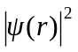 (which has a maximum only at r = 0). The “extra” 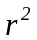 from looking at the function in spherical coordinates (that is, having the variable be “distance from the origin” rather than the cartesian coordinates) makes all the difference.

